**Probability** **Assignment**

**Homework 1.1**

Jerry and Susan have a joint bank account.

Jerry goes to the bank 20% of the days.

Susan goes there 30% of the days.

Together they are at the bank 8% of the days.

1. Susan was at the bank last Monday. What’s the probability that Jerry was there too?
2. Last Friday, Susan wasn’t at the bank. What’s the probability that Jerry was there?
3. Last Wednesday at least one of them was at the bank. What is the probability that both of them were there?

**Homework 1.2**

Harold and Sharon are studying for a test.

Harold’s chances of getting a “B” are 80%. Sharon’s chances of getting a “B” are 90%.

The probability of at least one of them getting a “B” is 91%.

1. What is the probability that only Harold gets a “B”?
2. What is the probability that only Sharon gets a “B”?
3. What is the probability that both won’t get a “B”?

**Homework 1.3**

Jerry and Susan have a joint bank account. Jerry goes to the bank 20% of the days. Susan goes there 30% of the days.  
Together they are at the bank 8% of the days.

Are the events “Jerry is at the bank” and “Susan is at the bank” independent?

**Homework 1.4**

You roll 2 dice.

1. Are the events “the sum is 6” and “the second die shows 5” independent?
2. Are the events “the sum is 7” and “the first die shows 5” independent?

**Homework 1.5**



An oil company is considering drilling in either TX, AK and NJ. The company may operate in only one state. There is 60% chance the company will choose TX and 10% chance – NJ.

There is 30% chance of finding oil in TX, 20% - in AK, and 10% - in NJ.

1. What’s the probability of finding oil?
2. The company decided to drill and found oil. What is the probability that they drilled in TX?

**Homework 1.6**



The following slide shows the survival status of individual passengers on the Titanic. Use this information to answer the following questions

1. ◼  What is the probability that a passenger did not survive?
2. ◼  What is the probability that a passenger was staying in the first class?
3. ◼  Given that a passenger survived, what is the probability that the passenger was staying in the first class?
4. ◼  Are survival and staying in the first class independent?
5. ◼  Given that a passenger survived, what is the probability that the passenger was staying in the first class and the passenger was a child?
6. ◼  Given that a passenger survived, what is the probability that the passenger was an adult?
7. ◼  Given that a passenger survived, are age and staying in the first class independent?

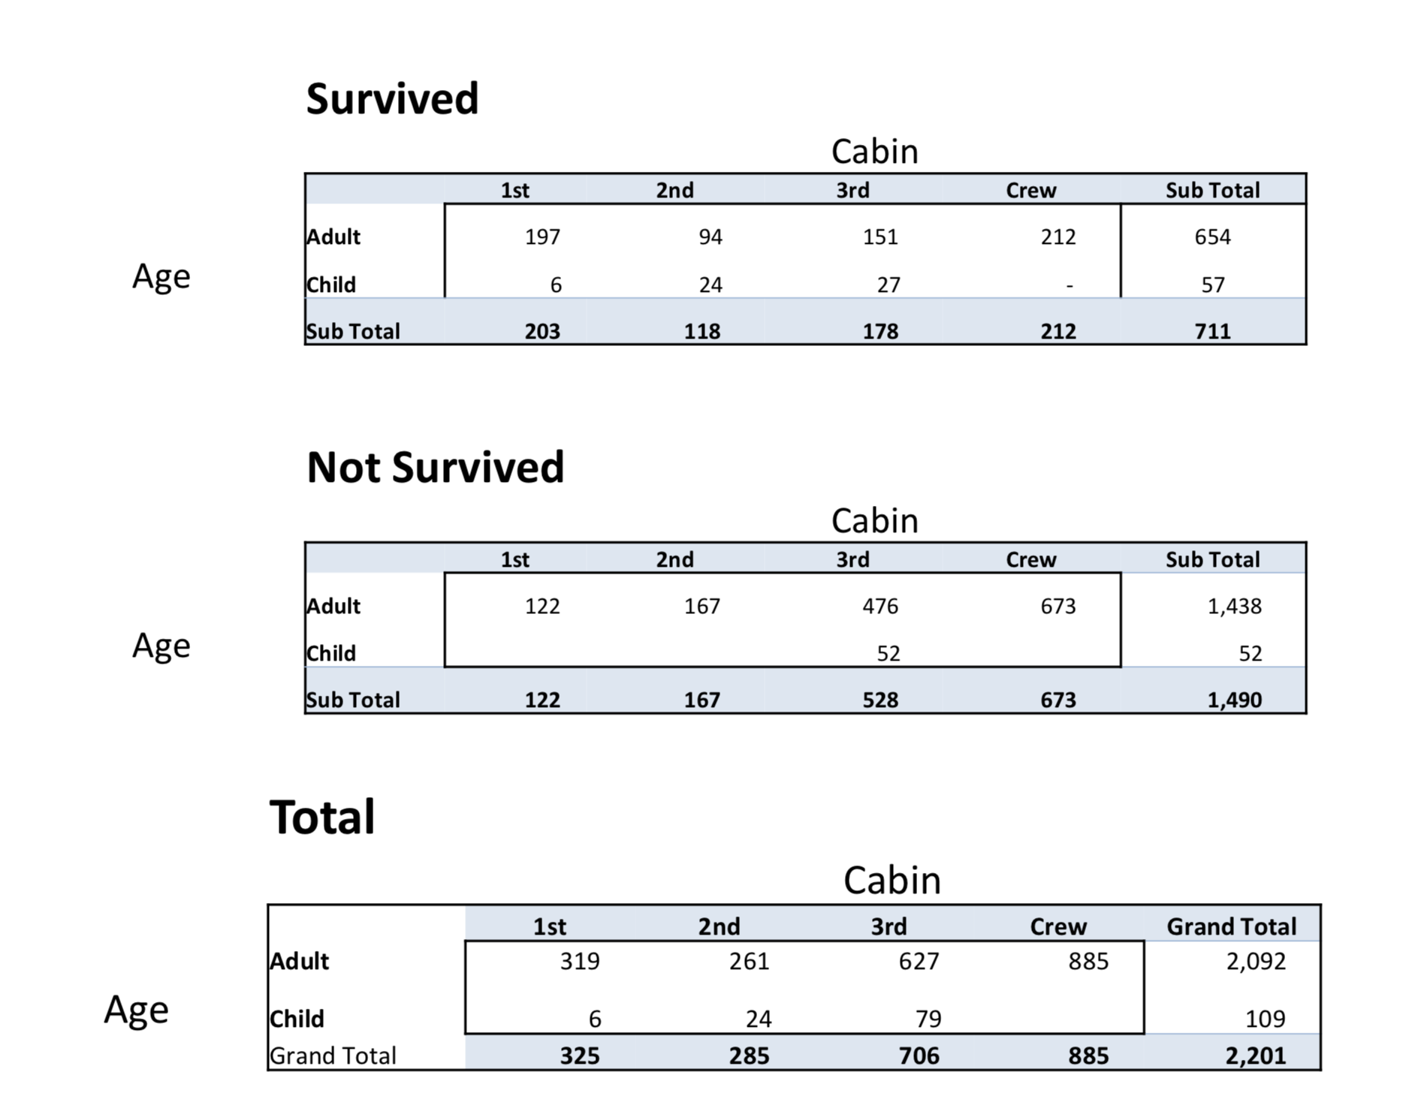

**Homework 1.7**

